ARYAMAN MISHRA 19BCE1027 ESHAN DAS 19BCE1575

**Macro level activity diagram with swim lanes for movie recommendation system**

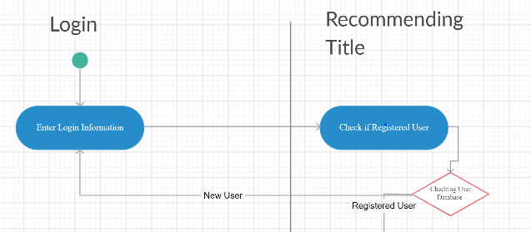

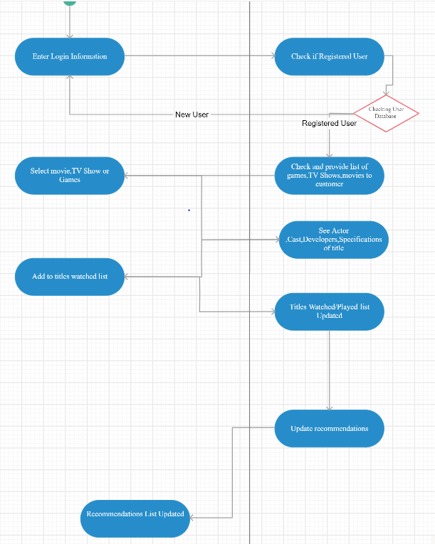

**Recommendation by recording ratings and sorting items** (use case)

